***Virginia Junior Classical League***

*presents this*

Certificate of Excellence

*to*

Conner Vandevander

*of*

Turner Ashby High School

*for*

*8th Place in Mythology*

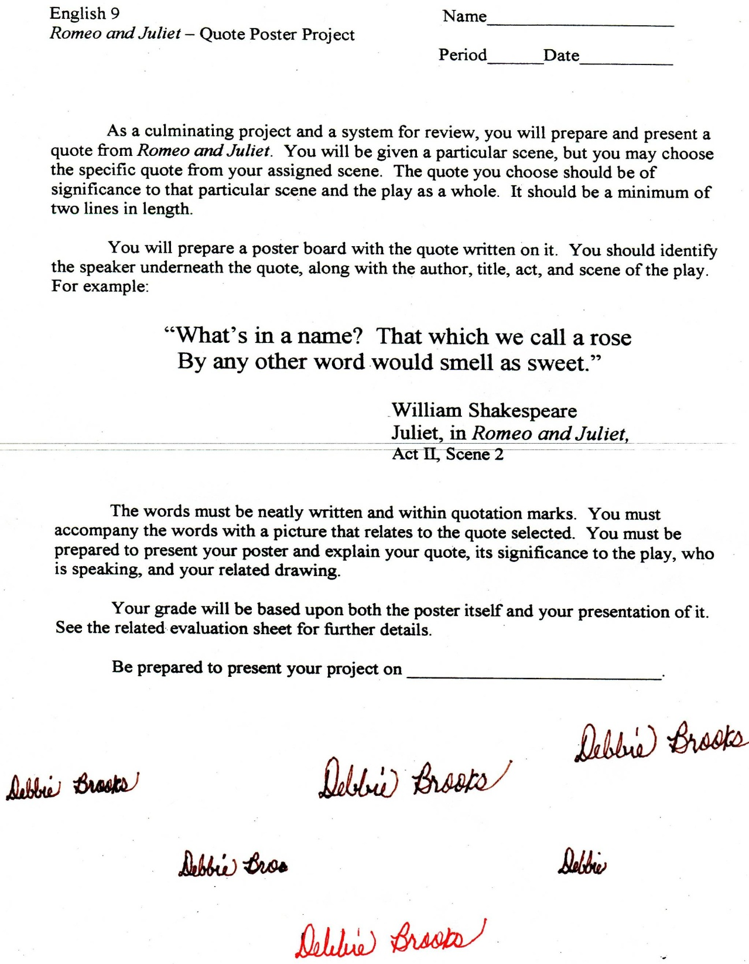

Microsoft Office Signature Line...

*a.d. viii Kal. Dec. MMDCCLXVII A.U.C. 